**Nutrition Assistant Manager**

Dibyendu Ghosh

1941012595.h.dibyendughosh@gmail.com

### 1 INTRODUCTION

**1.1 Description**

This project is a web application that returns nutritional values of the food items that the user has uploaded as an image. This is achieved by using Flask which is a famous python library. I have also used MySQL to store credentials and APIs that provide me with nutritional information namely IBM Watson Visual Recognition and USDA database.

**1.2 Purpose**

Nutrition today is a very big concern for all individuals. With the amount of junk food consumption the world is moving to a very unhealthy place. Nutritionists serve as guides to manage our diet and make sure we do not have an unhealthy lifestyle but not everybody can afford a personal nutritionist. This is where our app comes in, it is an inexpensive way to find out how much calorie you would be consuming and therefore manage it yourself. Not only this teaches discipline but also makes you healthy.

### 2 LITERATURE SURVEY

**2.1 Existing problem**

Similar kinds of applications available on the internet are text based. They return you nutritional values based on a text input such as food input but that does not reflect how much calories your food might have.

**2.2 Proposed solution**

Same food might have different calorific values for different ways of cooking. This application is however image based so it can understand more details. If you are not consuming the full dish but only a part of it you can upload the part of food you are consuming and it will return values for only the amount you are consuming. Thus image based nutrition management systems perform better.

### 3 THEORETICAL ANALYSIS

**3.1 Block diagram Diagrammatic overview of the project.**

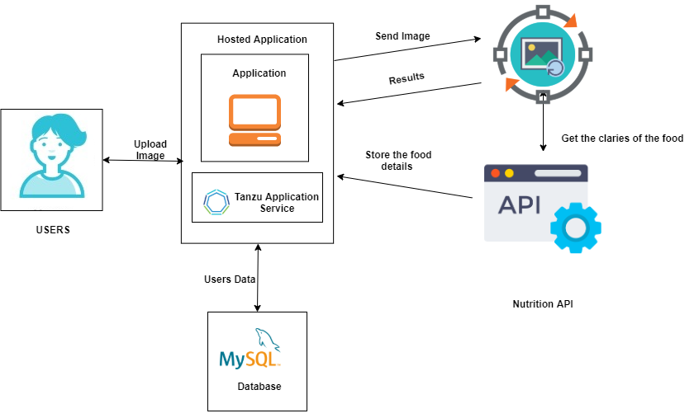

**3.2 Hardware / Software**

Hardware requirements: Working PC, internet connection

Software requirements: Python3, Remote MySQL, XAMPP, docker,

### 4 EXPERIMENTAL INVESTIGATIONS

1. Understanding how to insert and fetch data from MySQL
2. Understanding how to work with APIs - fetch response from various APIs and parse the response they returned (mostly in .json format)
3. Learning how to style using HTML and CSS
4. Learning how to build images, and use existing images from hub.docker.com

### 5 FLOWCHART



### 6 RESULT

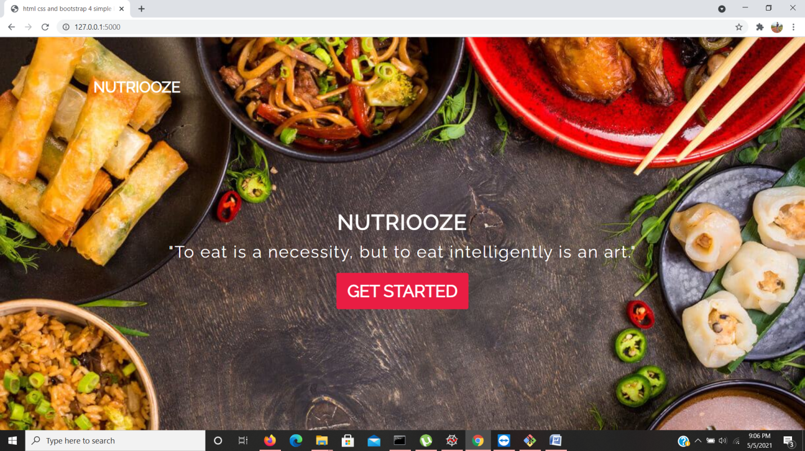

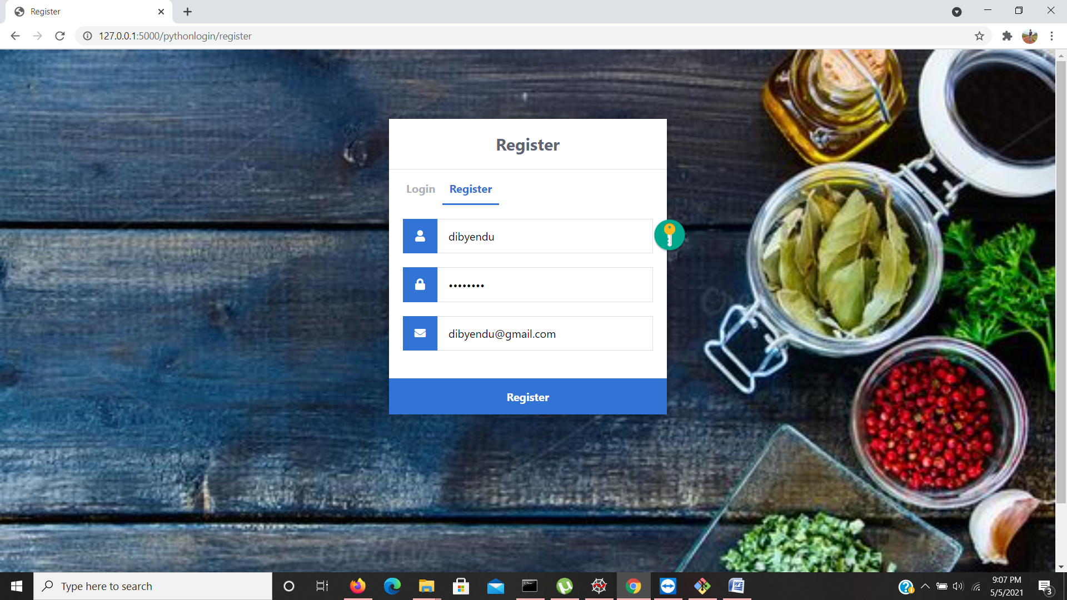

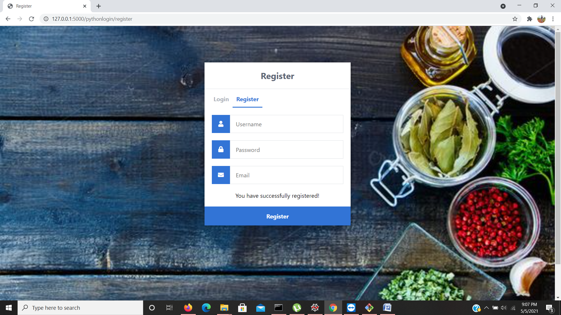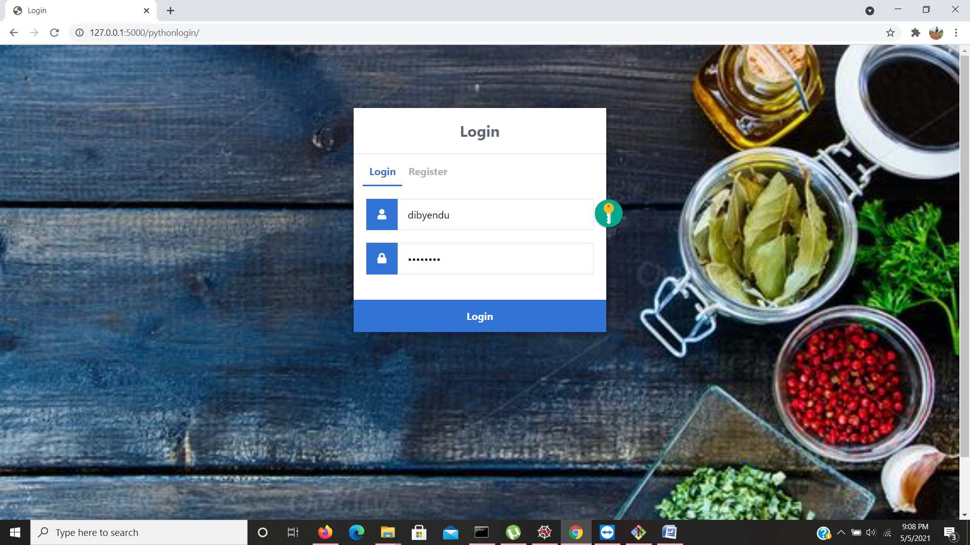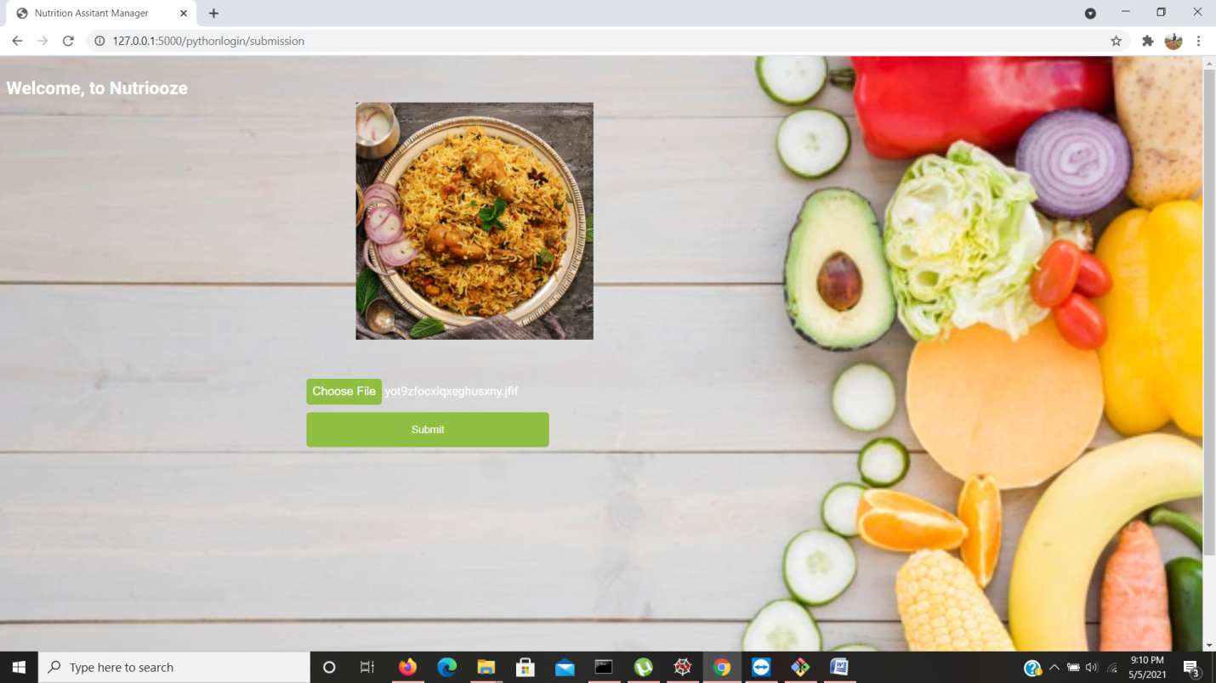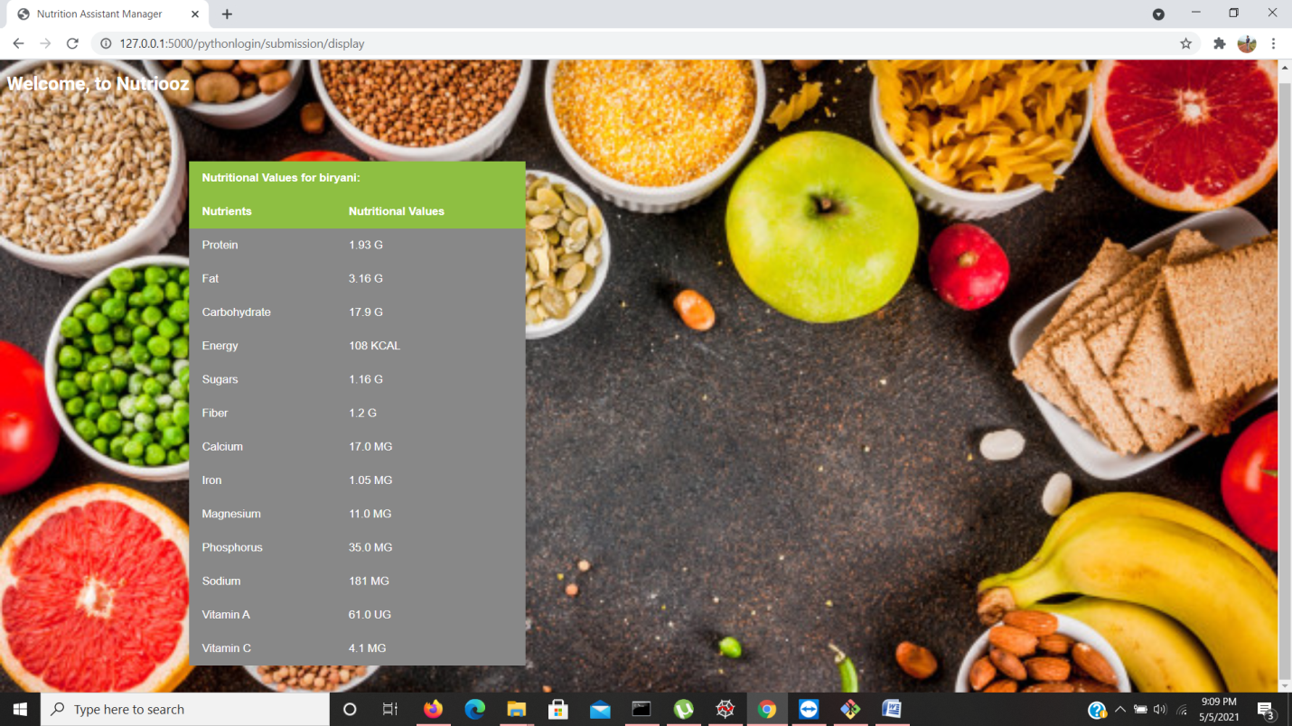

### 7 ADVANTAGES & DISADVANTAGES

Advantages:

1. Provides better information on nutritional values by using visual recognition.
2. Can understand if a item is branded and then provide nutritional values of the specific brand
3. Can distinguish between different amount of servings

Disadvantage:

1. Can misclassify similar looking food
2. Can not determine specific ingredients from food items

### 8 APPLICATIONS

Applications for a Nutrition Assistant Manager are vast. Some of the more common ones are:

* Fitness Tracker/ Calorie Tracker
* Medical Apps for patients with high cholesterol or sugar etc.

### 9 CONCLUSION

This project has been a challenge that was fun to overcome. So many ideas incorporated into a single application makes up for a good challenge. The application is not 100% accurate as foods can look similar. The ingredients in the dishes cannot be distinguished in certain scenarios so the application is not able to predict correctly. Besides these constraints the application provides very good information.

### 10 FUTURE SCOPE

Enhancements that can be made in the future:

1. UI Improvement
2. Scaling the application to handle more requests
3. Building mobile app for mobile users.

### 11 BIBLIOGRAPHY

[1]<https://www.w3schools.com/html/> - W3schools html guide

[2]<https://www.w3schools.com/w3css/defaulT.asp> - W3schools CSS

[3]<https://smartinternz.com/Student/badge_workspace/9775> - SmartInternz dashboard

[4]<https://fdc.nal.usda.gov/api-guide.html> - USDA APi docs

[5]<https://cloud.ibm.com/apidocs/visual-recognition/visual-recognition-v3?code=python> - IBM Watson Visual Recognition API docs

### APPENDIX

**A. Source Code**

from flask import Flask, render_template, request, redirect, url_for, session

from flask_mysqldb import MySQL

import requests, json, os

from ibm_watson import VisualRecognitionV3

from ibm_cloud_sdk_core.authenticators import IAMAuthenticator

import MySQLdb.cursors

import re

app = Flask(__name__)

# Change this to your secret key (can be anything, it's for extra protection)

app.secret_key = 'deek1234'

# Enter your database connection details below

app.config['MYSQL_HOST'] = 'remotemysql.com'

app.config["MYSQL_PORT"] = 3306

app.config['MYSQL_USER'] = '4of66GAB8K'

app.config['MYSQL_PASSWORD'] = 'ZCre1Gh7Pu'

app.config['MYSQL_DB'] = '4of66GAB8K'

# Intialize MySQL

mysql = MySQL(app)

@app.route('/')

def home():

return render_template('home.html')

# http://localhost:5000/pythonlogin/ - this will be the login page, we need to use both GET and POST requests

@app.route('/pythonlogin/', methods=['GET', 'POST'])

def login():

# Output message if something goes wrong...

msg = ''

# Check if "username" and "password" POST requests exist (user submitted form)

if request.method == 'POST' and 'username' in request.form and 'password' in request.form:

# Create variables for easy access

username = request.form['username']

password = request.form['password']

# Check if account exists using MySQL

cursor = mysql.connection.cursor(MySQLdb.cursors.DictCursor)

cursor.execute('SELECT * FROM accounts WHERE username = %s AND password = %s', (username, password,))

# Fetch one record and return result

account = cursor.fetchone()

# If account exists in accounts table in out database

if account:

# Create session data, we can access this data in other routes

session['loggedin'] = True

session['id'] = account['id']

session['username'] = account['username']

# Redirect to home page

return redirect(url_for('submission'))

else:

# Account doesnt exist or username/password incorrect

msg = 'Incorrect username/password!'

# Show the login form with message (if any)

return render_template('index.html', msg=msg)

# http://localhost:5000/python/logout - this will be the logout page

@app.route('/pythonlogin/logout')

def logout():

# Remove session data, this will log the user out

session.pop('loggedin', None)

session.pop('id', None)

session.pop('username', None)

# Redirect to login page

return redirect(url_for('login'))

# http://localhost:5000/pythinlogin/register - this will be the registration page, we need to use both GET and POST requests

@app.route('/pythonlogin/register', methods=['GET', 'POST'])

def register():

# Output message if something goes wrong...

msg = ''

# Check if "username", "password" and "email" POST requests exist (user submitted form)

if request.method == 'POST' and 'username' in request.form and 'password' in request.form and 'email' in request.form:

# Create variables for easy access

username = request.form['username']

password = request.form['password']

email = request.form['email']

# Check if account exists using MySQL

cursor = mysql.connection.cursor(MySQLdb.cursors.DictCursor)

cursor.execute('SELECT * FROM accounts WHERE username = %s', (username,))

account = cursor.fetchone()

# If account exists show error and validation checks

if account:

msg = 'Account already exists!'

elif not re.match(r'[^@]+@[^@]+\.[^@]+', email):

msg = 'Invalid email address!'

elif not re.match(r'[A-Za-z0-9]+', username):

msg = 'Username must contain only characters and numbers!'

elif not username or not password or not email:

msg = 'Please fill out the form!'

else:

# Account doesnt exists and the form data is valid, now insert new account into accounts table

cursor.execute('INSERT INTO accounts VALUES (NULL, %s, %s, %s)', (username, password, email,))

mysql.connection.commit()

msg = 'You have successfully registered!'

elif request.method == 'POST':

# Form is empty... (no POST data)

msg = 'Please fill out the form!'

# Show registration form with message (if any)

return render_template('register.html', msg=msg)

# http://localhost:5000/pythinlogin/home - this will be the home page, only accessible for loggedin users

@app.route('/pythonlogin/submission')

def submission():

# Check if user is loggedin

if 'loggedin' in session:

# User is loggedin show them the home page

return render_template('submission.html', username=session['username'])

# User is not loggedin redirect to login page

return redirect(url_for('login'))

@app.route('/pythonlogin/submission/display', methods = ["POST", "GET"])

def display():

if request.method == "POST":

image = request.files["food"]

authenticator = IAMAuthenticator('2A6BucKErMHbNpKGwdyGMBTsAZYxRYmm8Rxr0chzTvfm')

visual_recognition = VisualRecognitionV3(

version='2018-03-19',

authenticator=authenticator)

visual_recognition.set_service_url('https://api.us-south.visual-recognition.watson.cloud.ibm.com/instances/80c78105-880f-4bb7-b79c-93764795ee73')

classes = visual_recognition.classify(images_filename=image.filename,

images_file=image ,classifier_ids='food').get_result()

data=json.loads(json.dumps(classes,indent=4))

foodName=data["images"][0]['classifiers'][0]["classes"][0]["class"]

nutrients = {}

USDAapiKey = '9f8yGs19GGo5ExPpBj7fqjKOFlXXxkJdMyJKXwG3'

response = requests.get('https://api.nal.usda.gov/fdc/v1/foods/search?api_key={}&query={}&requireAllWords={}'.format(USDAapiKey, foodName, True))

data = json.loads(response.text)

concepts = data['foods'][0]['foodNutrients']

arr = ["Sugars","Energy", "Vitamin A","Vitamin D","Vitamin B", "Vitamin C", "Protein","Fiber","Iron","Magnesium",

"Phosphorus","Cholestrol","Carbohydrate","Total lipid (fat)", "Sodium", "Calcium",]

for x in concepts:

if x['nutrientName'].split(',')[0] in arr:

if(x['nutrientName'].split(',')[0]=="Total lipid (fat)"):

nutrients['Fat'] = str(x['value'])+" " + x['unitName']

else:

nutrients[x['nutrientName'].split(',')[0]] = str(x['value'])+" " +x['unitName']

return render_template('display.html', x = foodName, data = nutrients, account = session['username'])

else:

return render_template('submission.html')

if __name__=='__main__':

app.run(debug=True)